Fake Currency Detector

# Prof.A.M.Dyade1

**Mr Atharv Davale2, Mr Rushikesh Waghule3, Mr Digvijay Shinde4,**

Assistant Professor, Department of Computer science and Engineering**1** Student, Department of Computer Science and Engineering**2,3,4**

SVERI’s College of Engineering, Punyashlok Ahilyadevi Holkar Solapur Vidyapeeth., Gopalpur, Pandharpur,

Maharashtra, India

**Abstract**: The creation and circulation of counterfeit notes are on the rise right now, as a result of advances in color-printing technology. This is a serious issue that affects practically all of the nations. The economy is impacted. According to the research, this has had a highly negative effect on developing nations like India. This research suggests a method for viewing the fake currency through its image. Various Pre-processing techniques should be used after choosing an image. After that, the image is segmented, its features are measured, correlation is found, and classification is completed to determine whether the image is real or fake. Banks and other trading places have equipment available to verify financial validity. Nevertheless, the normal individual does not have access to such tools. This project provides a thorough explanation of a fake note detector that can be used by the average person. The Python programming language has been used to create the software in its entirety.

**Keywords**: Fake Currency, image processing, grayscale conversion, segmentation, pre-processing.

1. **INTRODUCTION**

Currency duplication or production of counterfeit currency notes illegally by imitating the actual manufacturing process is a huge problem that every country is facing. Fake currency can reduce the value of real money and cause inflation due to an unauthorized and unnatural increase in the money supply. Manual authentication of currency notes is a solution but it is a very time-consuming, inaccurate, and difficult process. Automatic testing of currency notes is, therefore, necessary for handling large volumes of currency notes and then, getting accurate results in a very short time span. In this project, we propose a fake currency note detection system using various image processing techniques and algorithms. The proposed system is designed to validate Indian currency notes of denomination 500 and 2000 rupees.

# LITERATURE SURVEY

1. Ms. Monali Patil, Prof. Jayant Adhikari, Prof. Rajesh Babu they proposed a system which uses image processing to distinguishes between features of a real note and a fake note. They used K-means algorithm for feature clustering and SVM algorithm to train their data model. (Patil, 2018)
2. Mayadevi A.Gaikwad,Vaijinath V. Bhosle Vaibhav D Patil. In their research paper they have suggested a methodology of detecting fake currency from the real by comparing their visual features such as distance between Gandhiji’s portrait and other notations. This methodology can be useful for a system purely based on software processing. (Gaikwad, 2017)
3. VigneshMK,SuryaV.In their paper they have suggested image processing along with supervised machine learning to learn the distinguishing feature of a real note from fake one which will increase the precision of this method. (Kumar, 2023)
4. Akanksha Upadhyaya Research Scholar, Vinod Shokeen Associate Professor, Garima Srivastava. In their study they have proved that image processing along with logistic regression gives an accuracy of above 99%. (Upadhyaya , 2018)

# REMETHODOLOGY

1. **Preparation of Dataset:**The first step is the preparation of a dataset containing images of different currency notes (both fake and real) and images of different features of each of the currency notes • The dataset will contain the following repositories: – Sub- dataset for Rs. 500 currency notes 1) Images of real notes 2) Images of fake notes 3) Multiple images of each security feature (template) – Sub- dataset of Rs. 2000 currency notes (Similar structure)
2. **Image Acquisition**: Next, the image of the test- currency note is taken as input and fed it into the system. The image
3. should be taken from a digital camera or preferably, using a scanner. The image should have a proper resolution, proper brightness and should not be hazy or unclear. Blurred images and images with less detail may adversely affect the performance of the system. (Refer Fig3.1)
4. **Pre-processing**: Next, the pre-processing of the input image is done. In this step, first the image is resized to a fixed size. A fixed size of image makes a lot of computations simpler. Next up, image smoothening is performed by using Gaussian Blurring method. Gaussian blurring removes a lot of noise present in the image and increases the efficiency of the system.(Refer Fig3.3)
5. **Gray- scale conversion**: Gray scale conversion is mainly used because an RGB image has 3 channels whereas a gray image has only one channel. This makes the computation and processing on images much more easier in the case of gray scaled images. Refer fig3.4
6. **Algorithm**: CNN (Convolution Neural Network)In the realm of fake currency detector software, Convolutional Neural Network (CNN) algorithms play a pivotal role in enabling robust and accurate identification of counterfeit notes. This sophisticated technology utilizes a multi- layered neural network designed specifically for image recognition tasks. The software is trained on a diverse dataset comprising authentic and counterfeit currency images, allowing the CNN to learn intricate patterns, textures, and features

that distinguish genuine from fake money. During the detection process, a user inputs an image of a currency note, and the CNN meticulously analyzes the visual elements through convolutions, capturing hierarchical and spatial relationships. The deployment of CNNs in fake currency detection enhances the software's capability to discern subtle nuances, contributing to a more effective and reliable solution for identifying counterfeit currency with a high level of accuracy.

1. **Feature Extraction:** Now, using ORB location of each template has been detected in the input image within the highlighted area. The highlighted area is then cropped by slicing the 3D pixel matrix of the image. Next, we apply Gray scaling and Gaussian blur to further smoothen the image
2. **Edge Detection:** Edge detection is a crucial image processing technique employed in fake currency detectorsto enhance the identification of distinguishing features on currency notes. This technique focuses on identifying abrupt changes or transitions in intensity, which often correspond to edges or boundaries between different regions in an image. In the context of currency detection, edge detection helps highlight intricate patterns, fine details, and specific characteristics that may be indicative of genuine or counterfeit notes.

# IV SYSTEM ARCHITECTURE

(Figure 1)The architecture of a fake currency detector system comprises several interconnected modules to ensure accurate identification of counterfeit notes. Users input currency images, which undergo preprocessing to enhance quality. Feature extraction techniques, including edge detection and pattern recognition, highlight distinctive elements. A Convolutional Neural Network (CNN) is trained on a dataset to learn relevant patterns. The classification module combines CNN analysis and extracted features to determine authenticity. A user interface facilitates interaction, and the output module provides clear results. Integration with external systems, security measures, and mechanisms for continuous learning enhance system capabilities. This comprehensive architecture ensures the system's effectiveness in detecting counterfeit currency while maintaining user- friendly interaction and adaptability to evolving threats.

This model we will build will use a grayscale image, segmentation, and feature extraction. We are going to use OpenCV in this project because this library contains some of the pre-built functions to work with images. To check whether the currency is fake or real, we will take a real note and a fake note as input an image in the system. The input images given to the system will be converted into grayscale images. We will use segmentation to segment out the image of Gandhi Ji and the thin strip on the note.

The idea is that we will compare the real and fake notes based on the image of Gandhi Ji and the thin strip present on the image. We will compare the image of Gandhi Ji and we will check whether the number of lines in the thin strip is equal to the number of lines in the thin strip.

The comparison of Gandhi Ji’s image is simple because we just have to find a correlation between two images using a correlation function. If the result of the correlation function is greater than 0.5 then Gandhi Ji is legitimate and we will check for a thin strip. Otherwise, the note is fake.

Now the main problem is to find the number of lines in thin strips. For that, we will convert the image into HSV(hue saturation value) image because it will be easy that way. Then we will segment the image to find the thin strip.After that, we will apply a abel function to find the number of connected components i.e. the number of lines in the thin strip.In the end, we will just write small code to final check whether the currency is fake or real.

NOTE: We have just used two features i.e. Gandhi Ji image and thin strip. But there are a lot of other things on a real note like a unique number, bleed lines(using which a blind man can find what is the value of the currency), etc. For improving the model, you can try implementing these features by yourself.

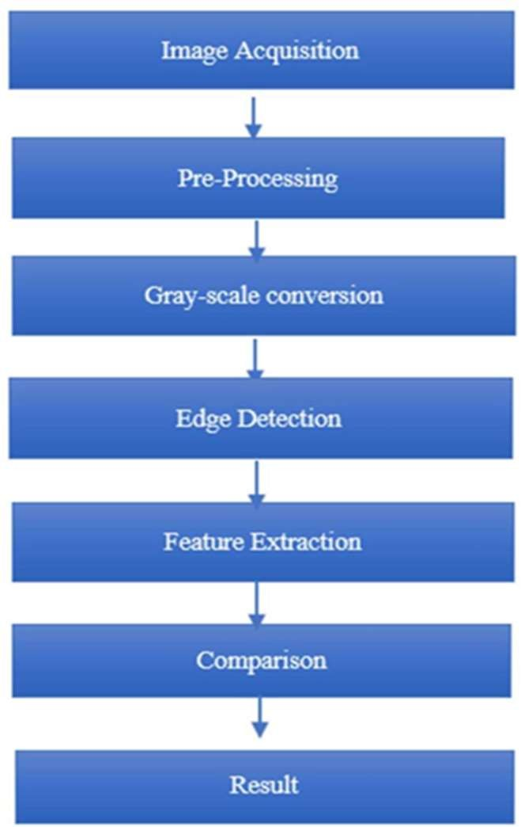

Dataset

*Figure 1 Flow diagram*

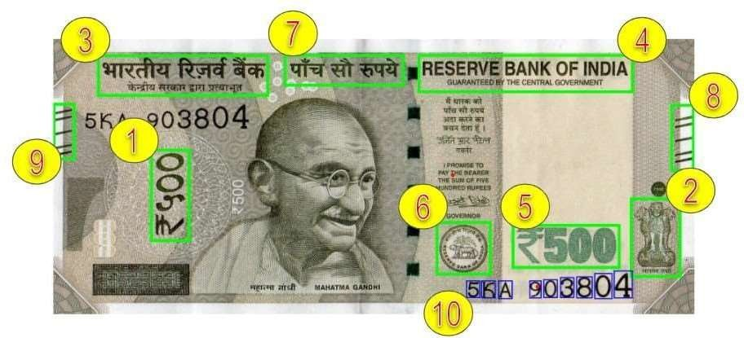

*Figure 2 Features in 500 | currency bill*

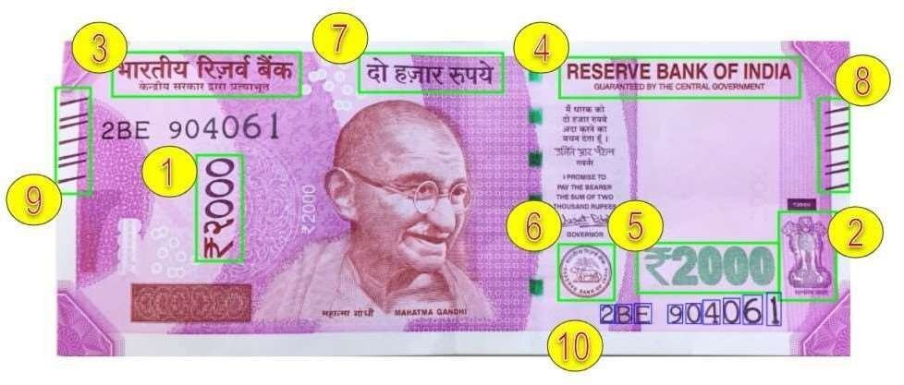

*Figure 3: Features in 2000 | currency bill*

# V Implementation

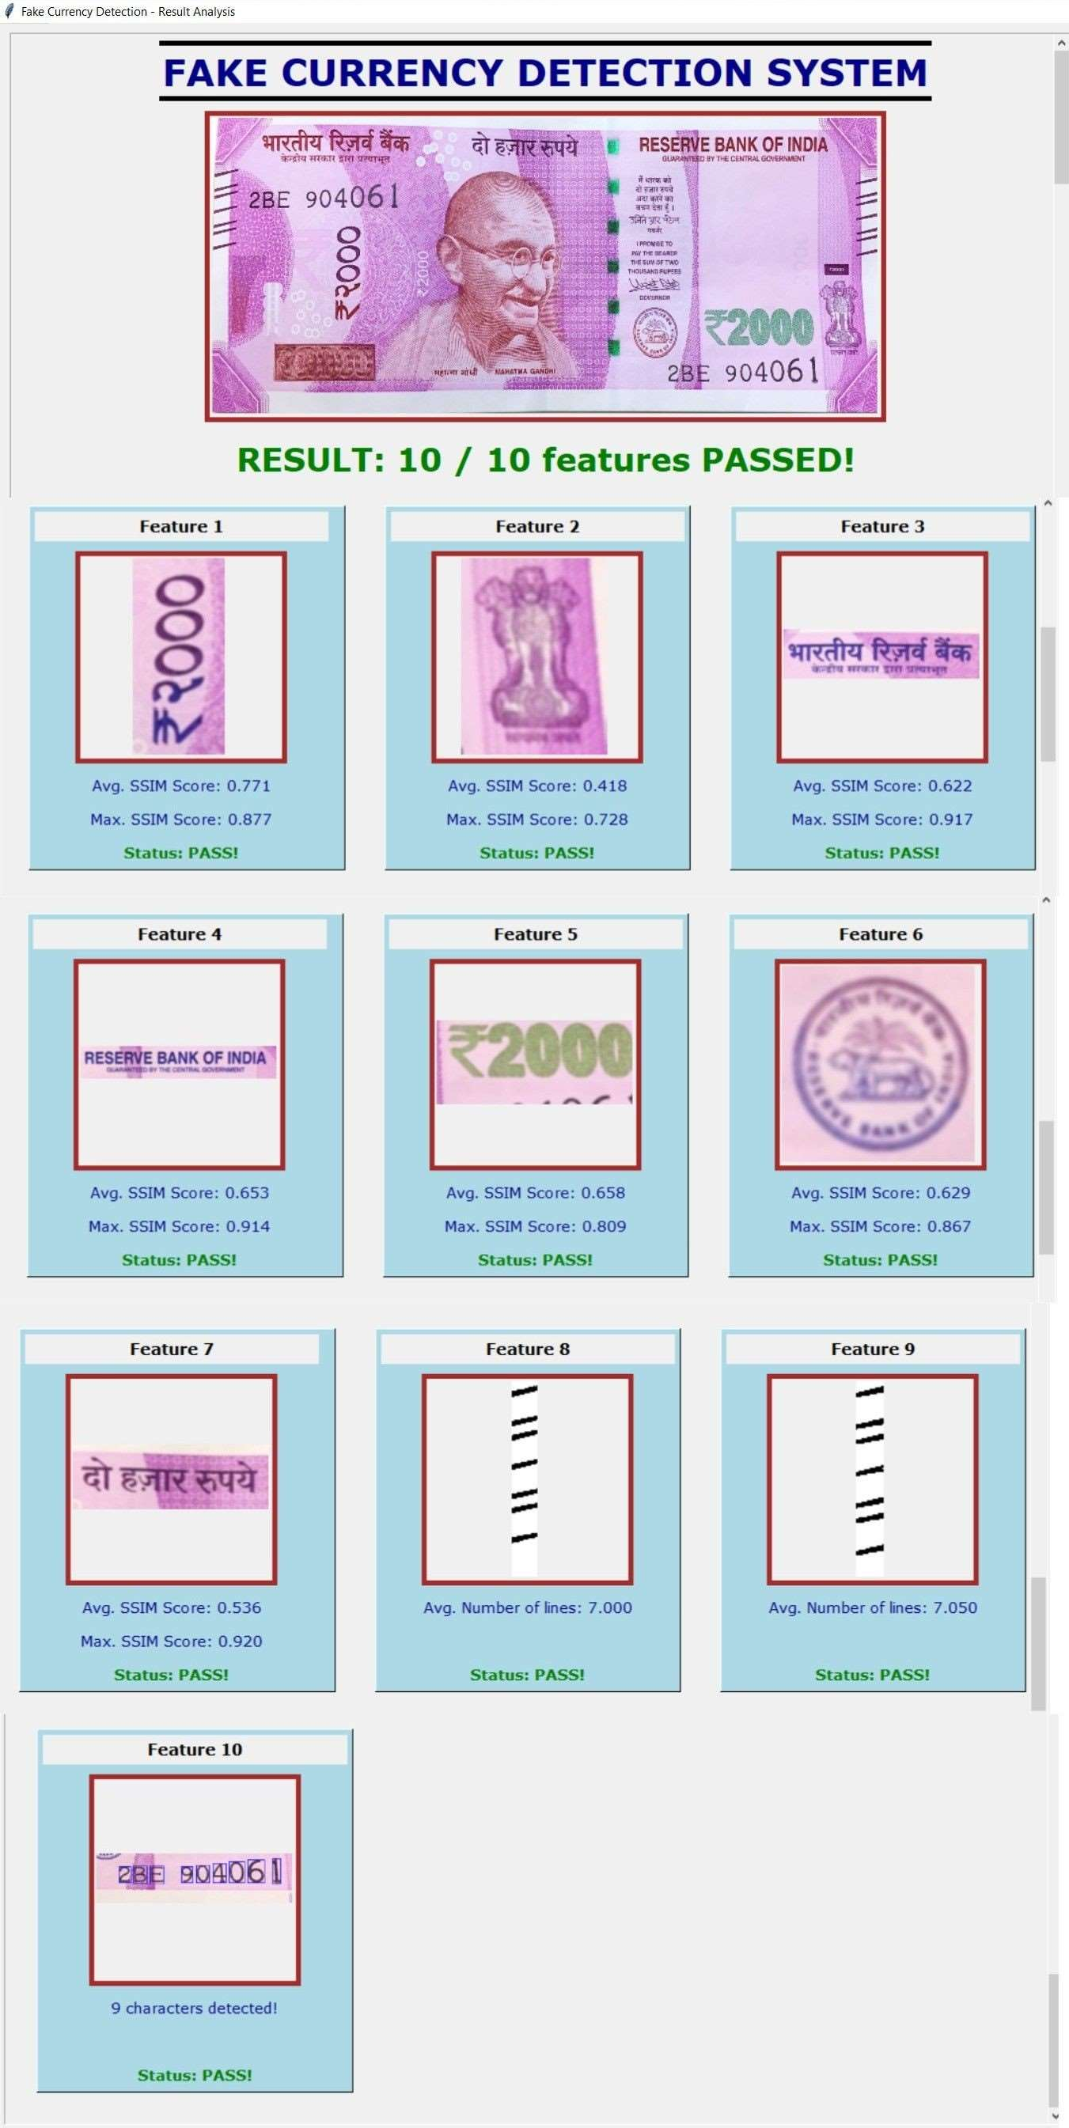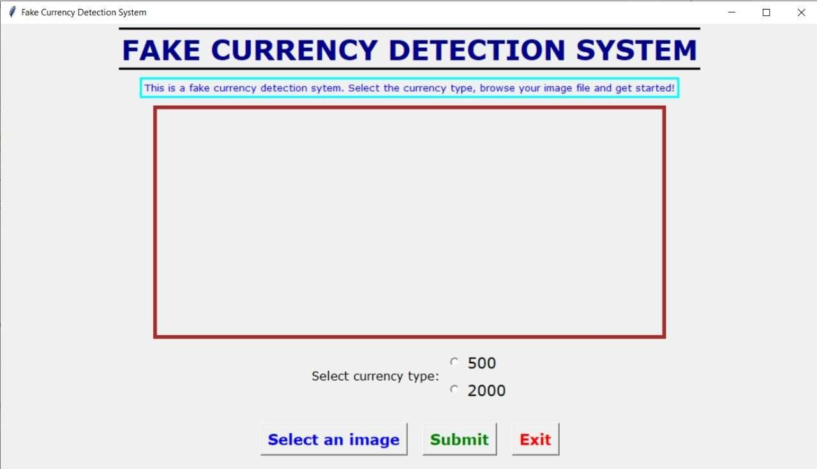

*Figure 4: Intially no image is dislayed*

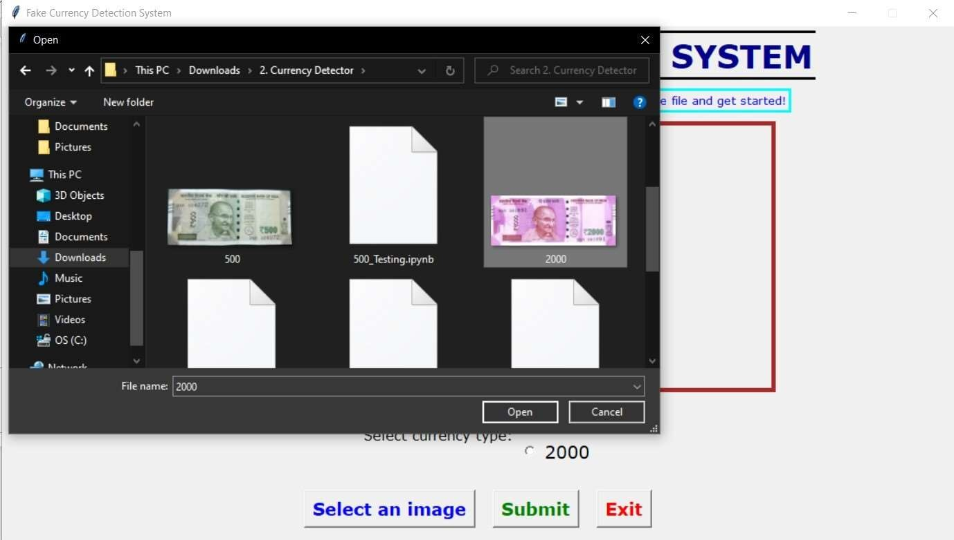

*Figure 4: Browsing image*

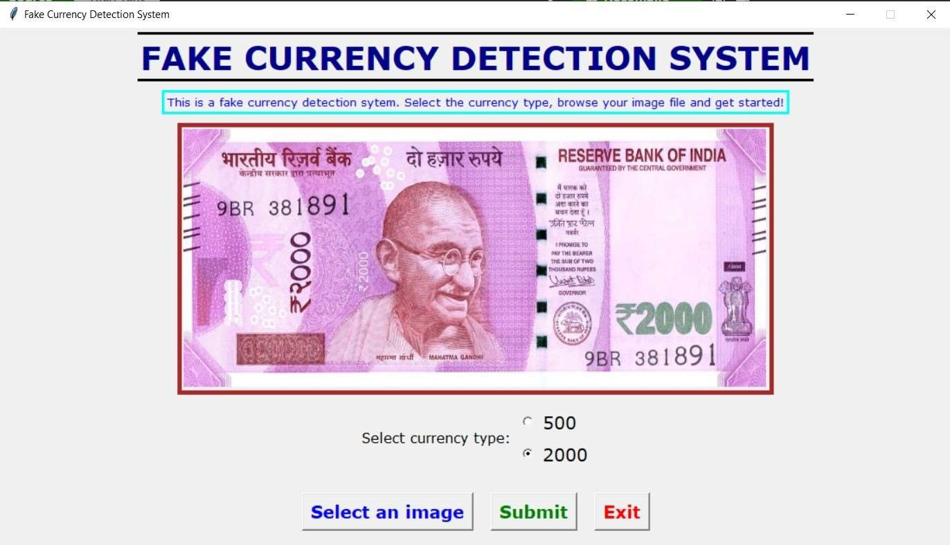

*Figure 5: Input image of currency not*

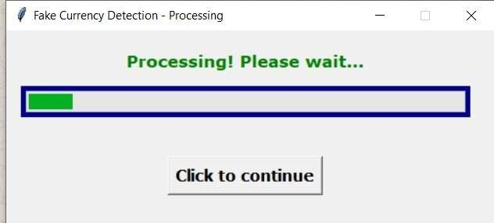

*Figure 6:Image sent for processing Figure7: GUI showing final result(Real note)*

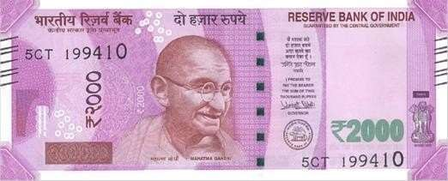

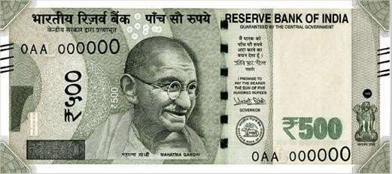

*Figure 8 :Original Note of Rs. 2000 and Rs. 500 as input*

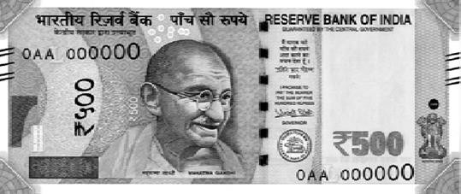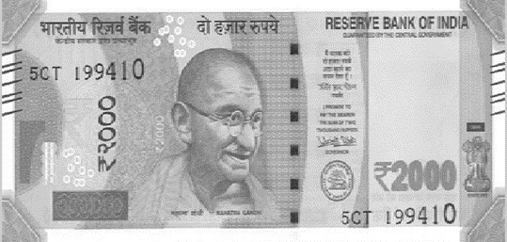

*Figure 9:* ***Grayscale Conversion of Rs.500 and Rs.2000 Note***

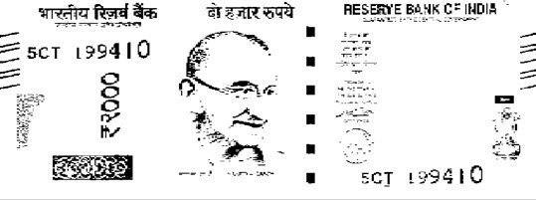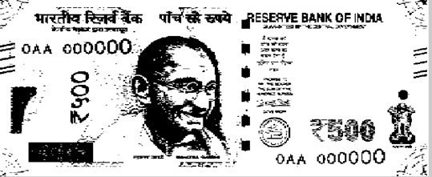

*Figure 10 :Grayscale Image to Black and White*

# CONCLUSION

In this paper, a fake currency detection model has been proposed for authentication of Indian currency notes of denomination 500 and 2000 and implemented using OpenCV image processing library in Python3. In this model, 10 features of the input currency note are considered and then analyzed using 3 different algorithms. The input image is taken through a GUI which allows the user to browse the image in his/ her system. Then the results of the implemented model are computed and the analysis of each feature is displayed in detail through a graphical user interface (GUI) created using Tkinter GUI library. The model takes less time (about 5 sec- when only final results are shown leaving unnecessary details) for processing an input image. The results are also quite decent giving almost 79% accuracy in detecting genuine currency and 83% accuracy in detecting counterfeit currency

# REFERENCES

1. (Darade, 2016) S. R. Darade and G. Gidveer, “Automatic recognition offake indian currency note,” in 2016 international conferenceon Electrical Power and Energy Systems (ICEPES). IEEE, 2016, pp. 290– 294.
2. (Yadav, 2014) B. P. Yadav, C. Patil, R. Karhe, and P. Patil, “An automatic recognition of fake indian paper currency note using matlab,” Int. J. Eng. Sci. Innov. Technol, vol. 3, pp. 560– 566,2014.
3. (Zarin, 2019) A. Zarin and J. Uddin, “A hybrid fake banknote detection model using ocr, face recognition and hough features,” in 2019 Cybersecurity and Cyberforensics Conference (CCC). IEEE, 2019, pp. 91–95.
4. M. S. Veling, M. J. P. Sawal, M. S. A. Bandekar, M.

T. C. Patil, and M. A. L. Sawant, “Fake indian currency recognition system by using matlab.” [5] F.

A. B, P. Mangayarkarasi, Akhilendu, A. A. S, and M. K, “Fake indian currency note recognition,” vol. 7, pp. 4766–4770, 2020. [Online]. Available: https://[www.irjet.net/archives/V7/i5/IRJET-](http://www.irjet.net/archives/V7/i5/IRJET-)

V7I5915.pdf

1. Santhanam K proposed, Polarization Principle and Holographic Technique in Image Processing
2. “Indian Currency Denomination Identification Using Image Processing Technique” by Vipin Kumar Jain,

Dr.Ritu Vijay

1. NM Joshi,RP Bajpai,G.Mitra proposed improved fake currency detector
2. “Paper Currency verification System Based On Characteristic Extraction Using Image Processing”, by Rubeena Mirza,Vinti Nanda
3. E. Muthukumaran, N. Mohanraju proposed Fake currency detection & stenography
4. An Automated recognition of Fake or Destroyed Indian currency notes in Machine vision" by Sanjana,

Manoj Diwakar, Anand Sharma

1. C.Yanqing proposed “Counterfeirt money and antisurvelliance measures”
2. Digital Image Processing by R. C. Gonzalez and R.

E.Woods

1. A Study on Diverse Recognition Techniques for Indian Currency Note” by Ms.Rumi Ghosh, Mr Rakesh Khare
2. A Novel Method for Counterfeit Banknote Detection”,by R. Bhavani, A. Karthikeyan